GUIDE TO THE ‘VIA AUGUSTA’

INTRODUCTION
Whilst there are websites from which you can access and print off guides to the Via Augusta, at the time of our undertaking this journey there was not a printed guide available in English. Furthermore, the reliability of the information provided within some of these guides is at times problematic. I decided therefore, that it would be helpful to construct a written guide for this route. The format of the guide seeks to give detailed descriptions to enable the walker to ‘navigate’ the route. This can be particularly challenging in the towns the route goes through to get to Seville. The guide also provides a hand drawn scale map of the different stages showing key features of each stage. The guide also provides information about the points of interest and the towns and villages the route takes the walker through along the way.

OVERVIEW
The Via Augusta starts at the Cathedral in what is reputedly the oldest city in the Western world; Cadiz and finishes at the cathedral in Seville. It covers a distance of between176 and 184 kilometres and can be walked in a period of between 6 and 10 days. We took six days to complete the route and therefore the guide is divided into the six stages, however the guide also indicates which and how particular stages could easily be split into two. At Utrera the route splits to give two options of how to get to Seville. This Guide covers the detail of the route that goes via Dos Hermanas. It is hoped to add the detail of the route that goes via Alcala de Guadaira at a later stage. This latter section is reputedly 42 kilometres, but can be split into two by staying at Alcala de Guadaira

The stages contained within the Guide are as follows:
Stage One: CADIZ to PUERTA REAL - 28 kilometres
Stage Two: PUERTA REAL to JEREZ - 26 kilometres
Stage Three: JEREZ to EL CUERVO – 30 kilometres
Stage Four: EL CUERVO to LAS CABESAZ – 26 kilometres
Stage Five: LAS CABESAZ to UTRERO – 32 kilometres
Stage Six: UTRERO to SEVILLA – 34 kilometres
Unlike the Via de La Plata accommodation along the route is mainly in hostals or small hotels, rather than in albergues or refugios. Few people walk the route and therefore you are not as likely to meet other ‘pilgrims’ whilst travelling along it. We met just one other person who was walking the Via Augusta on our journey. On all but two Stages there are towns and villages along the route with shops and accommodation that enable the walker to either get provisions/meals for the remainder of the days walk, or to break that stage into two.
The route is largely waymarked with the familiar yellow arrows and/or shell signs helpfully put in place by ‘friends of the camino’. However there are times where signage is non-existent or Spartan particularly in some of the more urban stretches and care should be taken at these times.

CADIZ
It is worth spending time in the beautiful city of Cadiz before embarking on your journey. Cadiz is reputedly the oldest city in the Western world and has a fascinating history. The old town in particular is worth exploring with its narrow streets, museums, churches and its cathedral. Long ago the city was an island but is now attached to the mainland by a strip of land bounded on one side by the Atlantic Ocean and on the other by the Bay of Cadiz. Its unique location was first discovered by the Venetians who reputedly established the first settlement there. At the peak of the Roman empire it was the third largest city in the Empire and the starting place for trading routes into and through Spain. It was the port that Columbus sailed from when he discovered the New World and it still remains a port of call for cruise-liners and cargo ships.
It has two magnificent beaches which stretch for four kilometres along its Atlantic sea front, running from the old city walls into the newer part of the city with its hotels, apartments and food outlets.

STAGE ONE MAP
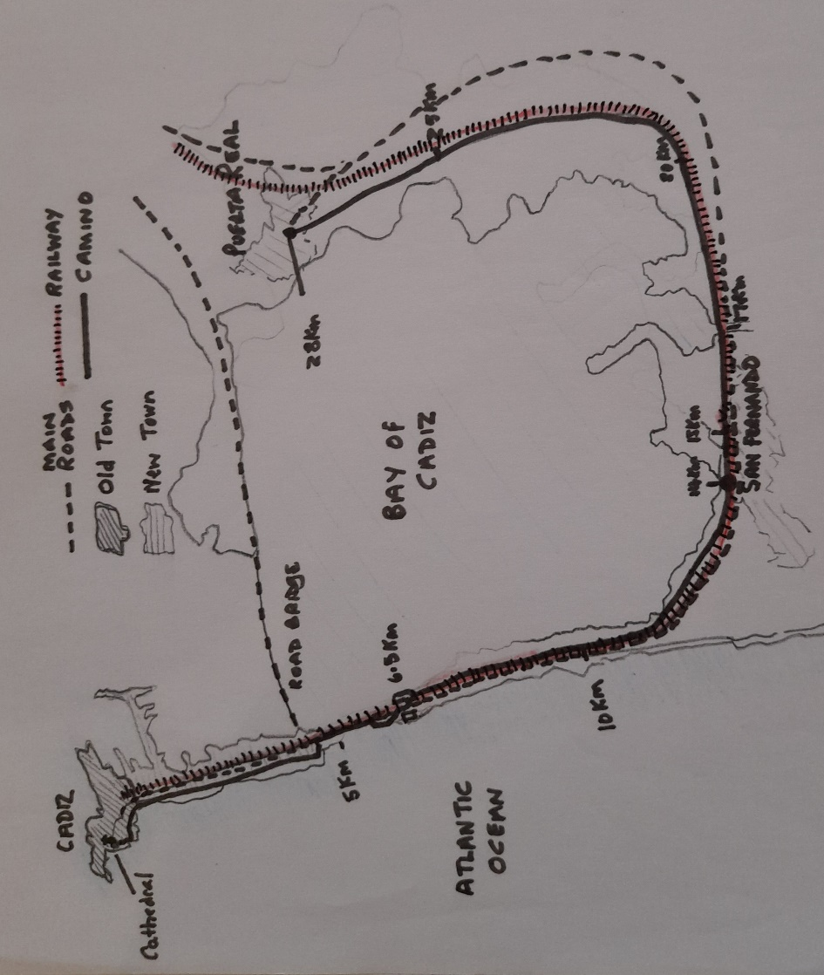
STAGE ONE
CADIZ TO PUERTA REAL (28 kilometres)
With your back to the cathedral and facing the Atlantic walk across the road (Av. Campo del Sur) to the esplanade and then turn left to walk along it. Your first way-mark, a combined arrow and shell should be visible on the wall of the esplanade. Continue to walk with the Atlantic Ocean to your right for a further 4.5 kilometres, passing as you do so from the old city into the new at the old city walls and then continuing past the two fine beaches of Santa Maria and Victoria. At a small car-park, when you can continue no further bear left and then after 20 metres right so that you are walking along the right hand side of the busy dual carriageway that takes traffic to and from the city to the rest of Spain Go past the Ventorillo del Chato again keeping to the right along the roadside. There are now dunes between the walker and the Atlantic Ocean and it is possible for part of the way to leave the road to walk on a path in the dunes. It is a choice between easier but noisier and slightly scarier pavement walking or slowing down, getting sand in your boots but feeling less vulnerable to passing cars.
After about 1.5 kilometres you should leave the road (if you have stayed on it) and head into the dunes to a blue and white marker with two clear yellow arrows on it. Turn sharp left to continue past a fenced in enclosure to your left, the sea is still beyond the dunes on your right. Follow the line of the fence until it ends and you arrive at a large unmade car park and head straight across this to a small wooden fence/barrier on the other side. Cross the barrier and follow the path through the dunes until you get back to a roundabout on the road. Go over the metal barrier and follow the road that takes you up and over the dual carriageway.
The naval garrison ( POLIGONO de TIRO NAVAL “JANER”) should be on your right as you start your walk up to the bridge. Once across the bridge bear sharp left and you are now walking back towards Cadiz with an area of ‘recreativa’ on your right and beyond that the Bay of Cadiz. At the bottom of the slope (200m) turn sharp left to double back on yourself and go under the bridge you have just walked across. You have walked the first 6.5 kilometres of Stage One.
You now have the railway line to your immediate right and beyond that the road. To your left are the mud flats, grassy banks, gullies and irrigation channels that stretch as far as you can see to the Bay of Cadiz beyond. This is an area of natural beauty and you will pass a number of ‘Parque Naturel’ signs to your left. You now have a long straight stretch along a wide track (5 kilometres) where the scenery changes little, until you come to a building to your left about 400metres away. Closer to is a stone arched gateway that leads along a track to the house. You will see the sign ‘DOLOR S’ just above the top of the arch. Looking ahead you can now see San Fernando in the distance.
Your track bends slowly round to the left as you approach the outskirts of the town and the distance between yourself and the railway line increases as you do so. A clump of trees on a bank ahead mark the spot where the railway returns to closer proximity and you are now entering the outskirts of San Fernando .Keep left along your track (Carrefor supermarket ahead left in the distance). You now are on tarmac and keep going straight until you are directed on the road that runs alongside the railway Calle Ferrocarril and keep on until the San Fernando Bahia Sur Station is on your right.
At the station you can go up and over a bridge which takes you over both railway and road and is the main entrance to the station, into San Fernando. There is a supermarket and a bar within 200 metres of the bridge crossing should you need to stop for a coffee and/or stock up on provisions. San Fernando has accommodation and you could break Stage One into two by staying here. You have covered 14 kilometres from your starting point. Back at the other side of the bridge you have a further 14 kilometres to get to Puerta Real.
Go straight on, parallel with the train track to your right, continuing along Calle Ferrocarril for about 1 kilometre until bearing right onto CalleTorero Rafael Ortega and at the end leave right (yellow arrow on a yellow background – not easy to spot) to get to the road that goes over the one you have left and cross to San Fernando Central Station ahead. Take the track down the right-hand side of the station as it dips down you have car-parking to your right and the track to your left. Turn left to go through an underpass which brings you to a track on the other side of the railway. Just before this is a small children’s playground on your right. It has seats and rubbish bins and is a good place to stop for lunch if you have not already done this in San Fernando Once through the underpass the railway will be immediately to your right and will remain there for most of the rest of the Day’s walk.
After a further 2km you arrive at the iron bridge to your right which carries a road over the bay to your left where a flotilla of little boats are moored.To your right the railway crosses the inlet too over a more modern bridge. Continue straight on and you again have the mud flats grassy banks, waterways and irrigation channels on your left, with the railway track on your right. At times there are wider stretches of water left but you have little shade until a bridge carrying a road across the railway provides brief shelter from the elements (5 kilometres beyond the iron bridge). Eventually the land to your left broadens out more and one or two fincas are in evidence with grazing pastures for cows and horses too.
Your track finally emerges, about 4.5 kilometres later onto tarmac on the fringes of Puerta Real, where you diagonally cross a roundabout to continue straight ahead, with glimpses of the sea to your left (Av. Jose Maria Fernandez G) A pleasant stroll into the centre of the town along this road which at the next roundabout becomes Calle Algeciras until you arrive at a large roundabout with a large metal structure of upright spars sculptured about three quarters of the way up to form an ellipse. Your route into town takes you straight ahead left (second exit) Signage is poor here so take care as the road ahead splits into a right and left hand route. The left hand one (Calle Real) becoming a one way street with cars coming towards you and the right hand one (Calle Huerta Pley) becoming a one way street with cars going in your direction of travel. Whichever route you take look out for a left turn along Calle Lenadores and then a right turn onto Calle de La Plaza. You will leave the town along this route at the start of Stage Two.
Puerta Real has a number of hotels and hostals and some good bars and restaurants too. Most of the hotels however are situated in an area about 400 metres inland from the old town through which Calle de La Plaza is the main pedestrianised thoroughfare.

STAGE TWO MAP
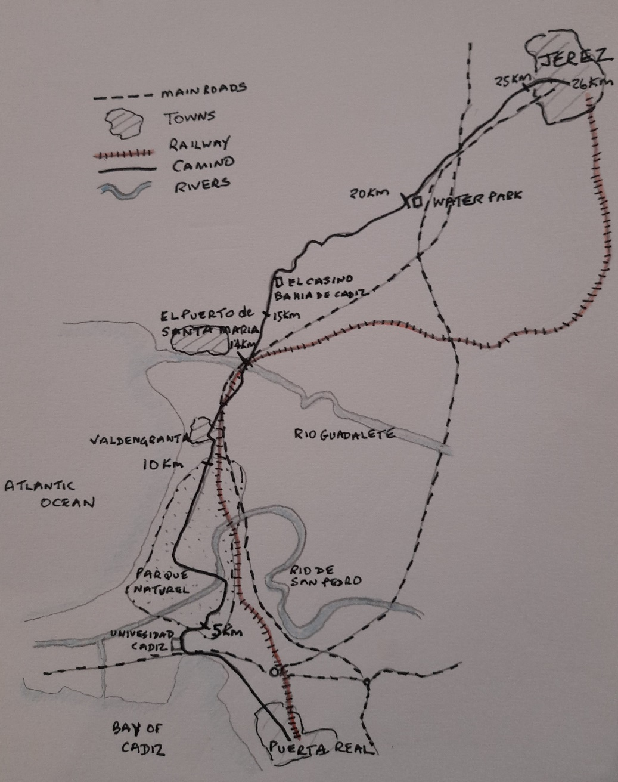
STAGE TWO
PUERTA REAL to JEREZ de la FRONTERA (26 Kilometres)
Leave Puerta Real heading northwards on Calle de La Plaza. Follow this pedestrian street until its end (approximately 400 metres) and then turn left ( Villa Mercedes is in front of you) and then shortly afterwards first right onto Calle Factoria Matagorda and then keep straight ahead as you head out of the town at a roundabout. Go over a bridge to your right at the University station and then follow the main route into the University complex. As you near the end of this road and with the main university buildings ahead, you will see a bicycle parking shelter on your right. You have walked 1.5 kilometres. Turn right immediately in front of this and the entrance to the Parque Natural and your Camino route is immediately ahead.
Keep straight on (slightly left) and keep to the main track as you progress through the park. There are no way-marks in evidence until you reach a clear marker at a junction indicating for you to go left. (a further 3 kilometres) Follow this route for a little while until you are directed to turn left again, and you are now walking on a long wooden bridge across the Rio Pedro. The wooden slats are old railway sleepers and stretch beyond the river and continue until you reach a shack with a seating area under cover (about 6 kilometres into the days’ walk).
Here you must turn right and follow a broad track for about 4 kilometres until you are directed to turn left into a Community Park Centre, which has a cafe and information about the history, geography and wildlife of the Parque Natural. You emerge from the cafe into the outskirts of El Puerta de Santa Maria. At the entrance to a roundabout a tall grey tower has a single window with 15 panes of glass and a pantile roof. A doorway has been painted on the front and a yellow arrow on the left indicates the route. The area you are in is called Valdelagrana and the main road you keep to is Av de Valdelagrana.
Keep on this main route between out of town shopping stores, supermarkets and restaurant chain outlets like McDonalds and Burger King. Cross a number of roundabouts, one with two pyramids in its centre. A second has a large boat as its centrepiece (La Nina) with a large sign for Burger King appearing at first to be its’ mast. The restaurant is behind it to the left. At a roundabout, where you can see the larger and older settlement of El Puerta de Santa Maria ahead and left across the river, keep straight on the main road, which now becomes Av de Europa before crossing a bridge over the Guadalete and entering the main settlement of El Puerto de Santa Maria.
This is the approximate halfway point of the day’s walk (12.5 kilometres) and for those wanting two shorter days El Puerto de Santa Maria has shops, restaurants and a number of hostels and hotels. From here onwards the Via Augusta heads almost due north for the first time as it heads inland to Jerez and eventually to Sevilla. Whether staying or not the town is worth a short detour, if only to pick up provisions and/or stop for a coffee or a bite to eat.
After crossing the bridge with the church; built in 1851 to your left, continue along the road signposted to Jerez and across a small roundabout and then bear left on the Avda de la Estacion. At the end of here at the roundabout turn right along the Avda Fray Bernal Boil. (Look for an arrow on the corner of an orange and white building) At a large roundabout take the second left turn along Calle Granje San Javier (in between a Driving School and a Veterinary Centre. After a short distance turn right at another roundabout along Av de la Diputacion. You are walking through the somewhat rundown suburbs of the town. A straight walk past Bar La Esperozza onto the next roundabout where you take the 2nd exit left onto Calle del Prior Juan Miguel Sanchez.
Keep on this road until a roundabout junction where a bridge carries another main road over your route. Take the right hand way under the bridge and then head across another smaller roundabout taking care to follow the arrows here. This will bring you onto a wide dual carriageway with street lights like palms leaning out into and over the road. At the roundabout at the end of this stretch (1.5km from El Puerto old town) your route goes straight ahead up a minor road that noticeably presents you with the first real climb of your journey since Cadiz. This road is Ctra del Juncal.
A fine house lies in front of you and to the left as you climb the hill and then the road bends sharply right and on your right is the Casino Bahia De Cadiz. Shortly after this you turn sharp left along a tarmac track that soon becomes an earth track. A large abandoned red building is ahead and to your left just before the tarmac changes to earth. You should take the broader track to the left and not the narrower one to the right. After about 400metres it is worth taking time to look back and in the distance see the road bridge between Cadiz and Puerta Real. It will probably be your last opportunity to look back to Cadiz.
At the next rise you can see Jerez ahead on the skyline. At the highest point of your gentle climb there is another abandoned building on your left. Just before this and to your right and below the Aqualand Bahia de Cadiz theme park can be seen and often heard too. It isn’t long before you can hear the familiar sound of traffic noise as the route runs along the left hand side of the motorway. The next stretch can be very muddy, especially after or during heavy rains.
A roundabout is reached after about a further 2 kilometres and your route takes you over the motorway and then down on a track to the left; this is the old road between Puerta Real and Jerez. Take care the first stretch is still used by cars. The motorway is now on your left and looking ahead and right you will see a big black bull on the horizon. Huge cacti reach twenty feet into the sky on your right and at a junction with a minor road you carry straight on. The bull you have been walking towards is now behind you.
Go downhill and you are now walking alongside the motorway with only a fence and a thin line of trees and bushes between you. Pass a ‘finca’ on your right ‘Olivar Matajaca’ and carry on with Jerez getting closer in the distance. At a building the route takes you right and then left to get round it and then bears to the right of the road that goes to a bridge over the motorway on your left. Your earthen track is now heading for the large white ‘finca’ you can see ahead. This is Vina Cardillo. Keep on the track you are on and this eventually brings you to the outskirts of Jerez. A further 2 kilometres of the days’ walk remains.
Keep straight along a road with new housing developments to your right. Keep straight on and Pass a ‘Carrefor’ on your right. You will now pass a large sherry factory to your left and a garage on your right. At the roundabout head left and then up towards the centre of the city with ‘Gonzalez Byass’ on your right walk along Calle de La Chapari. A gentle climb now to the old city then head diagonally right onto Ronda Caracol before heading diagonally left at a small roundabout past the Glorieta Manuel Azana sign. Follow the street which now takes you past a small Iglesia on your left with the taller tower of the Iglesia Santiago ahead. This is the finishing point for Stage Two. You have now covered 26 kilometres.
Jerez de La Frontera is well worth exploring with its Cathedral, bodegas, shops restaurants, museums and many smaller churches. It has a good number of hotels and hostals too. Famous for its sherry the city definitely has an air of affluence about it.
STAGETHREE MAP
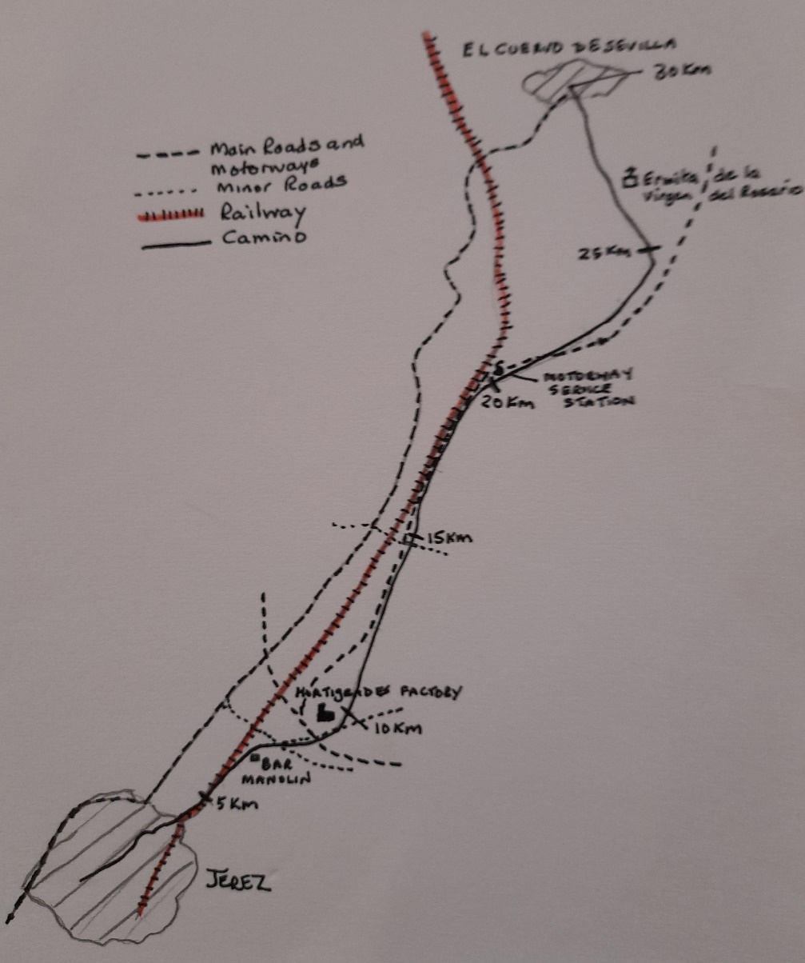
STAGE THREE
JEREZ TO EL CUERVO (30 Kilometres)
Make your way back to the Iglesia Santiago to rejoin the road you came along to arrive there yesterday and continue ahead on the same road, with the church on your left, passing another little Iglesia to your right until you turn right along a street named Guadelete and continue to a roundabout where you bear left. Tall palm trees will be on your left as you walk along a wide avenue. The long palatial avenue stretches way into the distance. It will keep you company for the next half an hour as you make your way out of Jerez. Pass the Conventa de Copuchinos on your left and go over a large roundabout with an iron horse in the middle and then finally arrive at another roundabout which is home to a comical caricature figure with arms akimbo and a hat perched at an angle on its head.
Here you turn right with the Hapiscor to your right. Cross at the next roundabout to go along Avenda de Espera and then take the right fork signposted to San Jose, before crossing the road to a path that takes you into a little park with red rectangular block seats. Ahead and to your right is the railway track. A retaining wall is adorned with a series of flying birds. Exit the park and turn left along Calle Cabo de Nao and then continue along a track with the railway to your right. This soon becomes an earth track. Eventually you turn right under the railway and then immediately left with allotments to your right. The railway is now on your left.
The route brings you out onto an unmade car park where you turn right past Bar Manolin (on your right) and continue along Calle Zarzales and then cross the road(left) at a crossing point to follow the CA-3104 road. This arrives at a roundabout with access roads to the E5 and AP4 motorways. A large factory is on your left with huge cylindrical containers. Ignore the first exit and go up and over the bridge and at the next roundabout head left towards the large HORTIGRADES factory (GADIRZAN) Keeping the factory to your left continue along an earth track. The path dog legs right and left and it is possible here to rejoin the minor road again at this point if the track you are on is very muddy, as it runs parallel with your path for about 400 metres.
If you take the road route you must rejoin the path again after 400 metres as the minor road now starts to bend right and takes you away from the Via Augusta. Shortly after this you are faced with two paths and need to take the left one which takes you across a bridge over the motorway. You then turn sharp right once across the bridge to come back under it so that you are walking parallel to the motorway which is on your left. Now keep on this path for a long stretch and enjoy the beautiful bushes and flowers. It can however be muddy after heavy rain. There are also cacti and prickly pears for company as well at times.
Gently rolling hills are seen ahead and to your right in the distance. The track emerges (briefly) onto tarmac again and you go past a road that goes over the motorway to your left. You carry straight on and soon regain an earth track once more. A motorway sign ahead and to your left informs motorists of a service station ahead and a fine house comes into view on your right. Go past a small finca and then a much larger one before a road goes over the motorway and your route must go over the base of the concrete mound holding up the supports of one end of the bridge. The motorway however remains your companion on your left.
The route brings you alongside a chain link fence alongside the service station and there is a gate to your left you can take to access the facilities there and obtain refreshments. On a rise to the right of the service station is a large black bull. The Camino goes around the buildings and continues along a track until you eventually arrive at an underpass that takes you under the motorway and has ‘El Cuervo’ beneath a large yellow arrow painted on the wall; (although you are still a long way from the town itself). The route now follows an earth track with the motorway to your right and this is another stretch where after heavy rains you will encounter ‘cloying’ mud. As compensation there are some pleasant views left and ahead.
After a little while a choice of tracks is presented; one to the right that clings to the motorway edge and the second to the left which veers off at a 20 degree angle from the motorway. Take the left hand track, again beware of cloying mud. Eventually this path arrives at tarmac and the large gate posts to a drive that one imagines will take you to a splendid house. Carry straight on right and then go over a tarmac road and keep left along an earth track with long distance views ahead. This brings you out at the entrance to a park on your right and ahead and you are directed to go into the park itself. Take care to keep left and your route, whilst very pleasant, is running parallel to the path on the outside of the park Your path brings you up to a small church with an information board about El Cuervo to your left. Pass by the left-hand side of the Ermita de la Virgen del Rosario and then turn left along a tarmac road.
It is now a further 3kilometres to El Cuervo and the Camino passes several splendid fincas and houses; one with peacocks; before the route bends sharp left and tarmac is left behind again as the route doubles back on itself and circumnavigates a reservoir to your left with allotments and trees to your right. Eventually you arrive at a Stop sign and cross over and turn right and go down into the small town of El Cuervo along Fernando De La Camara. There are a number of hostals and hotels and several bars and restaurants, to ensure all your needs for an evening meal and overnight stay can be met here.

STAGE FOUR MAP
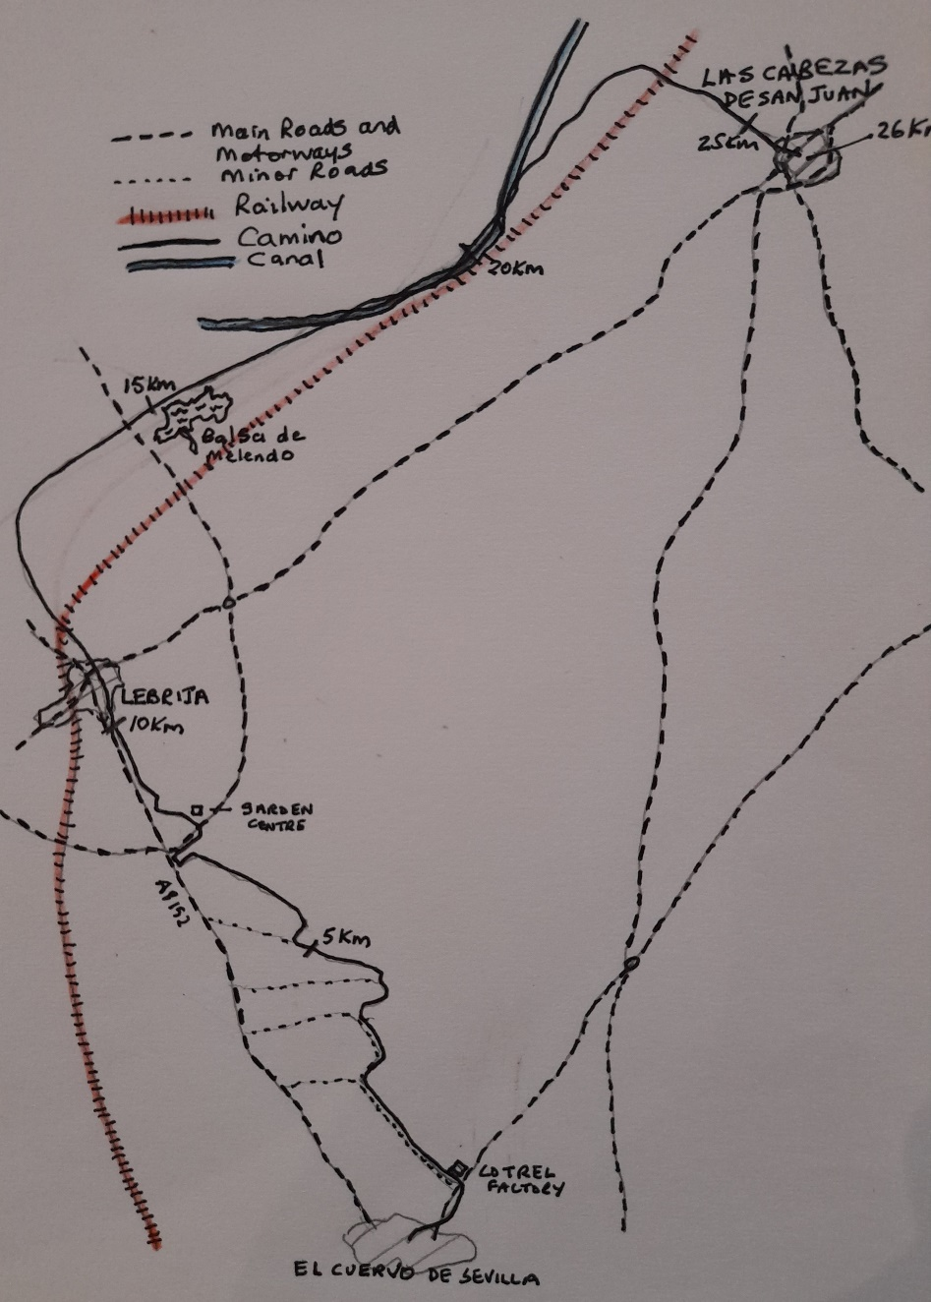
STAGE FOUR
EL CUERVO TO LAS CABESAZ (26 kilometres)
Leave the town by Avenue de Jose Antonio Gallego, heading north westwards then after a little while skirt the edge of a little park to your right before bearing left to join the main road. Take care here as you need to cross the road and go down a minor road down the side of Cotrel factory. Carry on down the track with the factory to your right and a hedgerow to your left, with railings on the other side. You will see a huge field of sunflowers to your right and along this route there are many more such fields to come with lots of little fincas and allotments too.
Take care to turn left at a crossroads and after a short stretch your route swings right again. Go past finca ‘El Nene’ on your right. The track opens out now and you have more expansive fields to either side and ahead. At a junction take the right-hand fork and head towards a larger finca on your left with a mast to your right ahead. Then turn right at a large telegraph pole and follow the line of wires to your right. You are now on a track between concrete posts with sunflowers behind the posts to your right. Eventually you arrive at a large factory where you turn left along the A 815 signposted Lebrija
On a left bend in the road your route turns sharp right and joins what was the old road for a short while before bearing right. You are walking alongside the busy highway and need to look out for an arrow on the ground to indicate the place to cross to re-join the old road on the other side towards a garden centre. Great care should be taken when crossing the road. To avoid this little detour do not turn off at the bend and carry on along the road over the new highway, which you will have to re-join again soon anyway.
The houses on the outskirts of Lebrija are just visible and even though the road sign says Lebrija 2 kilometres, that is to the centre of the town and within 200 metres you enter the town itself. Carry straight on until you come to a roundabout, where you will take a left turn. There is a café/bar opposite and you should now be on Avenda Jose Maria Tomasetti. Go past a roundabout with a Spanish pilgrim in a flatcap his stick and sack tied to its end over his right shoulder, in typical pose. Carry on until you arrive at another roundabout with a huge head in side profile and a small headless corpse in surreal pose. There is a Medical Centre on your right just before this roundabout. Turn right along Avenda Antonio Calvo Ruiz. You will have covered around 11 kilometres of the day’s walk by the time you reach this point and whilst Lebrija does have some accommodation and bars, you may feel as we did that continuing on for a further 15 kilometres to Las Cabesaz is the best option.
Continue along Avenda Antonio Calvo Ruiz and after a short while at another roundabout bear left and straight on with the Lebrija De Transportes HQ to your left. Carry on down this track (Camino del Fontanal) Another route keeps to the left hand-side of the road and eventually down a track to the left to meet the track that you are on. Keep straight on with expansive views across cornfields to your right. A little finca with some spectacular red blooms, looms up on your right too. Be careful here, the arrows suggest you go ahead and then left along the road, whereas your route is across the road and you now have a pleasant 2 kilometres beside the Embalse Melendo or Melendo’s Pond before you emerge beyond it with a large white building to your right on a hill.
Keep to the track you are on skirting the hill to the left and you now have a long open stretch with no shade. Look out after about 2 kilometres for a post and a large yellow arrow on a rock advising you to turn right towards a small white hut, ahead and right. This is opposite a well. Carry on and then bear immediately left beside the canal (Canal del Bajo Guadalquivir), This is at first a pleasant change to your route as you have the canal for company, but after several further kilometres, canal side walking may start to lose its appeal. After a while you cross over to now be walking along the other side of the canal, later still you cross again to return to walking along the left-hand side of the canal.
Finally, and just before a rise on which there is a vineyard, you cross over to the right for the final time and leave the canal behind. You will have covered eight kilometres since leaving Lebrijia and 19 kilometres of the days’ walk. Your destination (Las Cabezas de San Juan) can be seen ahead in the distance; still about 7 kilometres away. The track goes down sharp right before bearing left towards the town. A long winding track now is negotiated as you head towards the municipal tip (not very pleasant). Along this stretch there are at times options of different tracks to take. You need to stick to the main track (particularly in wet weather or after heavy rain). Even though it may take longer, the underfoot conditions are better, although in themselves not great after heavy rain (cloying mud).
After about 4 kilometres and with the tip finally behind you, the track brings you to several sheds and barns, where sheep and goats may be housed. Beware of ferocious dogs as you keep the barns to your right and walk on. If you ignore the dogs they will do you no harm, although they will remain aggressive and continue to bark until you have fully passed ‘their space’.
Your path now bends first left and then right and then rises until you arrive at a garage to your right. You are now on the edge of the town and must cross the bridge over the motorway to enter it. Keep to the main path, which becomes a road and walk up Calle Dr. Domingo Gallego until you come to the Bar La Tramontana where you take a left and then an immediate right on to Calle Sevilla to arrive in the Plaza Martinez del Pueblo in the centre of the town.
The only hostal in the town {Apartmentos Hostal Las Caezas) is situated at a roundabout on the corner of Avenue de Federico Garcia Lorca and Avenue Jesus Nazareno adjacent to the Plaza Martines del Pueblo. There are a number of bars and cafes nearby and a trip up past the Ayuntamento to the Parroquia de San Juan Bautista is worth a visit.

STAGE FIVE MAP
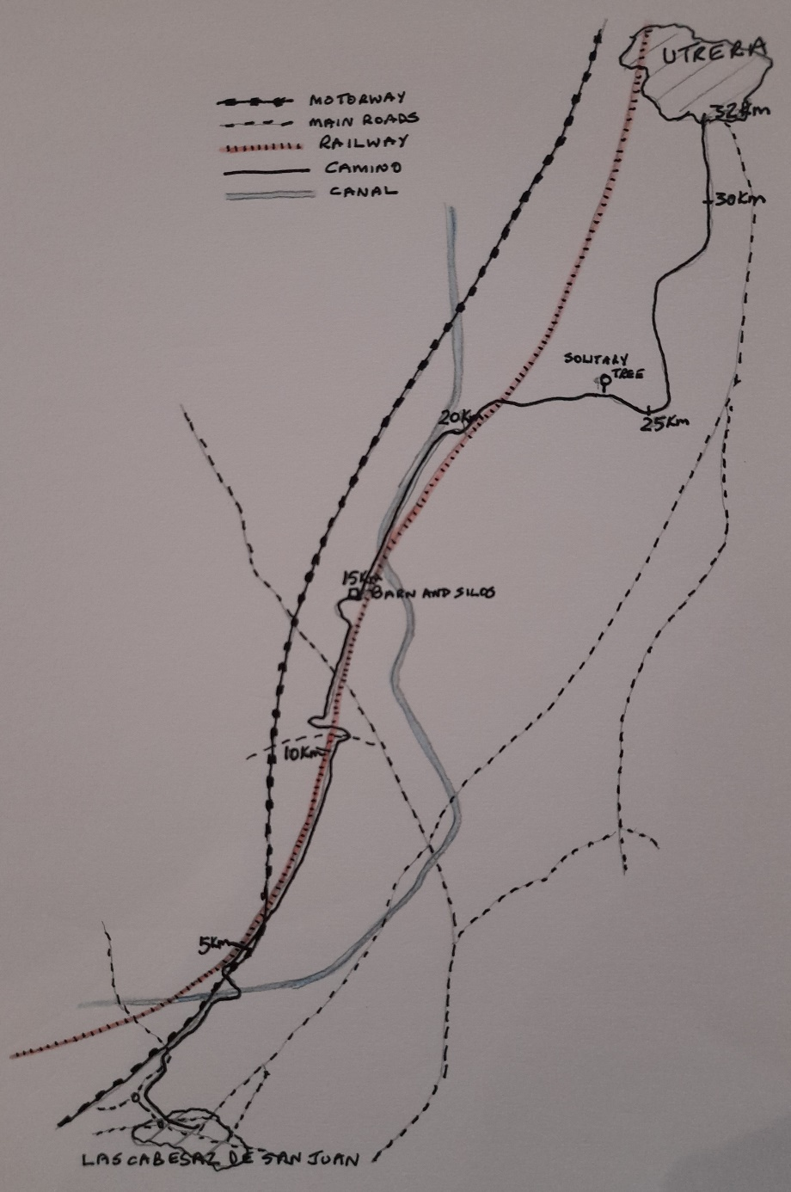
STAGE FIVE
LAS CABESAZ TO UTRERA ( 32 kilometres )
Leave the hostal and turn right immediately on to Av Jesus Nazareno and continue down the road which broadens into a wide avenue. Go straight across another small roundabout. Finally houses disappear on the right, but there are still habitations on your left as until you arrive at a second roundabout. Here you turn right and walk along the road parallel with the motorway to your left for two kilometres. At the two kilometres sign take great care to spot the turn, slight left, into a field and down a not very distinct path to reach the underneath of a road bridge. You would have gone over this bridge had you carried on waking along the road. Go under the bridge and you are again walking to start with on an indistinct path beside the motorway. This broadens out after a while and you continue straight on the broader path until you arrive at a canal.
At the canal you turn right so that you are now walking along the right-hand bank of the canal. This can be muddy underfoot after rain. After a short while you are directed over a bridge that takes you over the canal and are now heading round a large left-hand bend followed by a right-hand bend that takes you under the arches of the motorway and brings you on to a track running along the righthand side of the Cadiz to Sevilla railway line. Continue with the railway track to your left for a further six kilometres (ten kilometres from the day’s starting point).
You will arrive at a road bridge going over the railway with large boulders being part of its ramparts. This may provide one of the few places to sit and avoid the sun during today’s walk. Your route now takes you to the right to join the road that crosses the railway. Turn left and cross over the railway and drop down on the other side before taking a sharp right that takes you to a minor road that runs alongside the railway; now on your right. This whole manoeuvre covers around 800 metres and will bring you out directly opposite to and across the tracks from the boulders you may have rested on about ten minutes earlier.
Carry on for a further three kilometres on this minor road with reeds and bushes at times between you and the railway track. You will see a large barn in the distance and that is what you are heading towards. About a kilometre before the barn your route now bends left and after about 400 metres turn right along a road, which eventually swings left round a small cluster of trees. This brings you to a road and the barn you have been waling towards for some time is now upon you on your left. Keep on past the barn and its adjacent silos before you leave the road to walk along the right-hand side of the canal.
About 800 metres beyond you joining the canal side track there is an ermita on your left across the canal and a substation to your right. After a further two kilometres we leave the canal and turn right onto a track between the canal and the train track. After a further three kilometres the route bends to the right at a solo tree on your left. A further 800 metres later turn left and then turn left again in a further 1.5 kilometres. Another left turn is taken in about 1.3 kilometres. Utrera can be seen ahead. You have walked some 26 kilometres at this point and have a further 6 kilometres still to walk until Utrera is reached.
After a further 1.5 kilometres pass a factory on your left with a tarmac road ahead. Keep straight on for a further 1.2 kilometres and you will come to a sign that indicates that Utrera is 2.8 kilometres ahead. Keep left here and after a further 0.8 kilometres go under the road and then continue heading towards the town. The tower of the Iglesia de Santa Maria dominates the horizon as you enter the town itself.
The Iglesia de Santa Maria is probably the only example of Moorish architecture in the town. The Iglesia has an impressive portal and the tower has a baroque belfry. The church is located in Plaza Porche de Santa Maria There is also a gothic church; Iglesia de Santiago el Mayor located on Calle Gijon. The town also boasts two convents and a chapel; Santuario de Nuestra Senora de Consolacion The Iglesia de Santiago is the finishing point for this stage and the official starting point for tomorrow’s final stage to Sevilla.
Utrera has several hotels and hostals and a good range of places to eat an evening meal. After Jerez it is the largest town along the Via Augusta between Cadiz and Sevilla.

STAGE SIX MAP
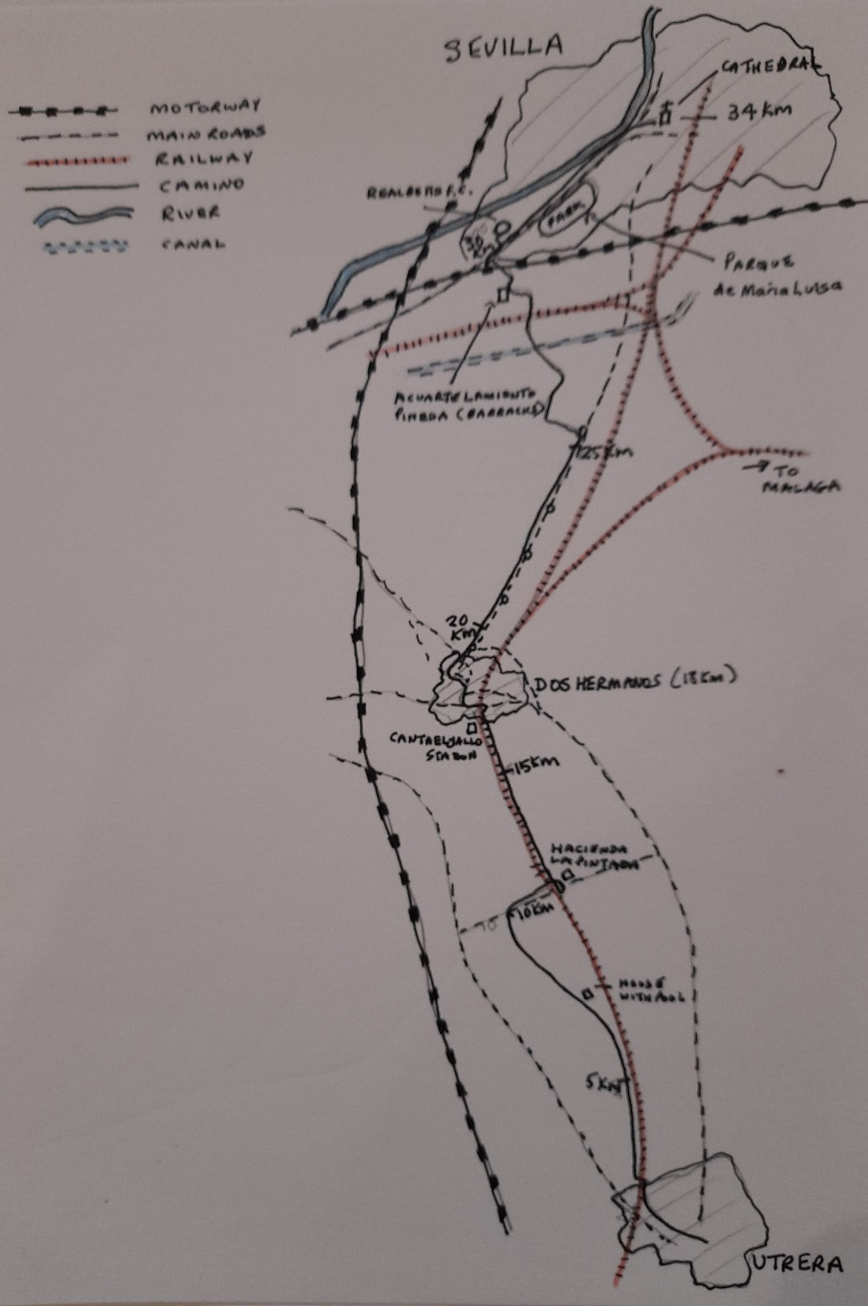
STAGE SIX
UTRERA TO SEVILLA (32 kilometre)
Retrace your steps to the Iglesia de Santiago and leave by the Calle la Fuente Vieja until you arrive at the roundabout at Plaza de Santa Ana and then take the second exit along Calle la Corredera passing the Hotel Veracruz on your right. Immediately after this take a left turn along Calle Vera Cruz. The railway track will appear on your left and you will arrive at a road bridge over the railway. Go up the steps to the main road and cross over the bridge and then go down the steps on the other side of the railway and join the Camino de los Callejones track that runs alongside the railway, which is on your right.
At first this stretch is not very pretty. There are a lot of barking dogs and small allotments. Eventually bend left and then right at a small roundabout to regain the track by the railway. However, it soon starts to deviate away to the left from the railway and the scenery improves significantly. At a junction of paths, the main path seems to bear right, but you keep straight, on the lesser of the two paths. Not only are you on the right path you will enjoy the most beautiful stretch of the Camino since leaving Cadiz.
You are now on a track lined with trees and bushes, with rabbits dashing hither and thither in front of you and occasional glimpses of colourful meadows or olive groves to either side. Keep going straight until the path arrives at a fine house with a swimming pool. Your track narrows but continue ahead with the house on your right and after a short while arrive at a tarmac road and then turn right along it. You have covered the first 10 kilometres of the day.
After a further kilometre along the road you arrive at the Hacienda la Pintada after crossing the railway. Just before the hacienda cross the road and go down the track back towards the railway on the other side of the road. (about a 200-metre deviation) Carry straight on here with the rail track now on your left After a further 3.1 kilometres arrive at a point that offers an alternative route. I ignored this and carried on with the railway still to my left. This route continues for a further 1.6 kilometres before arriving at a railway station ( Cantaelgallo) on the edge of Don Hermanos.
Follow the road past the station and then bear right to go down to a roundabout and then turn sharp left to go up and over the railway on the road bridge. On the other side of the bridge is a park on your right and you will pass an Evangelical Church, (Iglesia Evangelica Renaces) on your left. You are on the Ave de Espana. At the roundabout take the first right along Calle Real de Utrera. This eventually brings you to and alongside the Parroquia de Santa Maria Magdalena and you will arrive in the Plaza de la Constitucion. This is some 16.5 kilometres from your day’s start point.
Cross the Plaza and continue straight on along Calle Sta. Maria Magdalene. At the next major junction turn right along Calle Canonigo, which brings you to a large roundabout at the Plaza de Arenal, with Dos Hermanos station on the far side and to the right. Take care here to take your first left onto Ave Sevilla and continue until a further roundabout is reached. Take the second exit to keep straight on. Another roundabout is then negotiated and again you are keeping straight on and are now on Calle Libertad. At the next roundabout take the second exit ahead right along Calle Gabriel Miro, the Astoria café should be immediately on your left. At the next and final roundabout in Dos Hermanos go straight on right (second exit) and you are now on the wide avenue de Las Universidades, which you will keep to for another 3 kilometres. The Parque Dona Maria will shortly be passed on your right.
Keep on the tree lined Avenue de Las Universidades crossing two further roundabouts. Just beyond the second one the Supermarket Mercadona is on your right. Cross a third roundabout and then at a fourth leave the Avenue de Las Universidades to bear left, the Ermita Montequinto is on your left. Just before this roundabout a picnic place and assesseos will be seen over the road to your right. Follow the tarmac road and then onto an earth track to your right, which after 500 metres bears right along a line of trees, which eventually peter out so that you are walking in open countryside. Sevilla should be visible in the distance ahead. Carry on across the Canal des Bajo Guadalquivir on to a road (Calle Verada del Rayo) and after a short while cross to the left to take the road which you can see goes over a bridge across the railway tracks. Continue along this road until you come to a T junction and turn left.
You will shortly arrive at the barracks, Acuartelamiento Pineda, which you skirt to your left as the road bends sharp right. Keep on this minor road until you arrive at a major junction with the motorway, which skirts the city and the main route into the city; Ave de Jerez. At the junction turn left to a crossing which takes you to the central reservation of Ave de Jerez and your route continues between the inward and outward carriageways for 0.7 kilometres, before crossing left to the pavement that allows you to continue walking into the city with the road to your right. You have now covered 26.3 kilometres of today’s final leg of the Via de Augusta and have a splendid approach into the city of some 4.5 kilometres.
You are now walking along a grand avenue as you drop down into the city and will shortly pass the Real Betis football stadium on your left. The main avenue now becomes Av. De La Palmera. The magnificent Park of the Americas will be passed on your right (Parque de Maria Louisa). The many pavilions within the park represent and were commissioned by the different countries of the Americas and were constructed as part of the 1929 World Expo hosted by Spain. Just beyond the park the Public Library (Biblioteca Publica) is on your right. You are now on Paseo de las Delicias and the road bends left as you walk parallel to the River Guadalquivir. You are still on a wide avenue and below you to the left is a walkway along the banks of the river itself. You are now only 1.2 kilometres away from the cathedral.
Continue along your broad avenue crossing to the right-hand side when it is safe to do so. Turn right along Avenue de Roma with the Palacio de Sol Telmo on your right and continue straight on across Puerte de Jerez to arrive at the Cathedral, the finishing point of the Via Augusta and the starting point of the Via de La Plata.
Whether you are continuing beyond Sevilla along that route or finishing your journey here, it is well worth spending time in Sevilla, the capital of Andalusia. The cathedral, the giralda, the Alcazar palace, the park of the Americas and many more places are well worth a visit. Sevilla has an abundance of accommodation and of places to eat and many cultural experiences to enjoy. It is also the home of flamenco dancing.

